A-Team Tutorials

Level 1 with Tycho Tracker

Targets and Priorities
Which object should you select for a measurement? Of course, this will depend on your own interests for example:
- Easy asteroids or comets to practice using Astrometrica.
- Asteroids for which the Minor Planet Center (MPC) or European Space Agency (ESA) require measurements.
- Recent discoveries not yet confirmed.
- Recovery of objects that have not been seen for a long time.
If you are new to asteroid observing then it is best to start with some bright, slow-moving, easy ones and these can be found at the “What’s Observable” website or using your own planetarium software.

What’s Observable?
The easiest place to find what’s observable tonight is the What’s Observable? website. Go to the site and set up the search:
- Edit Observer Location to a Slooh observatory code. Press Edit, put G40 (Canaries), W88 (Chile) or E62 (Australia) in the Lookup the Specified Location box and press Search.
- Change the Observation time to a time when you believe there will be some free mission slots at your chosen telescope. This does not have to be precise, any time around the middle of the night will be OK.
- Set the Min elevation angle to 40 degrees to ensure you will have a good view of the objects.
- Move the slider next to Visual Magnitude and enter 13 – 16. That will give you a list of objects that are a reasonable brightness for this exercise.
- You can usually leave the rest of the constraints to the default.
- Select “Retrieve Data” (it may take some time).

Set up What’s Observable? query.
You will get a list of objects like this:
List of objects
The list will contain lots of objects visible from your chosen observatory. Look for some that have convenient rise/set times.
- Check the Object-Earth-Moon angle (deg). This tells you how far away from the Moon the object will be in the sky. It’s best to go for objects that are at least 60 degrees away from the Moon otherwise stray light from the Moon can ruin your images.
You can see lots of technical details about an object by clicking on its name.
Select a few of the objects you might be interested in and make a note of their names or numbers.

Planetarium software
You will sometimes need to use planetarium software to display star (and asteroid) maps. There are lots of commercial and free packages available and you may already have your own favourite. Make sure you are familiar with the functions to download asteroid data, filter asteroids by magnitude and display them on the map.
(I am currently using C2A because of its flexible handling of comets and asteroids – and it’s free!)
A star map showing asteroids can be a convenient way of selecting interesting observation targets. Set up the map for a time near the availability of Slooh missions and set to one of the Slooh observatory locations.
Filter your asteroid database to magnitudes 13 to 16. Examine the map for objects that are not too near the horizon and not too near the Moon.
Asteroids in a C2A chart.

Visibility and Missions
Now it is time to make a final decision on which object you are going to target, obtain its exact coordinates, set up the missions and (weather willing!) a few hours later download the results.

JPL Horizons or MPC?
You need to get detailed information about an object’s visibility to the Slooh telescopes. Some Slooh members may already be familiar with using JPL Horizons to obtain this data. There is no reason why they should not continue to do so if they find that system easier to use. However, it may be worth learning to use the MPC (Minor Planet Centre) Ephemeris pages (described below) because:
- You can copy and paste a plain text candidates list directly into the selection page.
- You can get information for all your candidates at the same time.
- You get information about whether new observations are needed and the uncertainty of the position.
- All the information needed to assess the viability of a mission is immediately available.
The MPC Site has many pages and navigating within the site can be complicated. For Level 1 you will only need to select Observers/Ephemeris Service but it is worth spending a bit of time exploring other parts of the site as they will be needed in due course.

Ephemeris
“Ephemeris” is a fancy word for a list showing the coordinates of an object at different times.
At this stage I am assuming you have a few names or numbers of potential targets, and you know what missions are available for one of the Slooh Telescopes. Go to the MPC Ephemeris page, enter the list of targets into the objects box (you can copy and paste the entire list into the box as long as it just contains object names, numbers or designations each on a separate line.)
The MPC will recognise an object in several ways:
- For an un-numbered object use its Provisional Designation (e.g., 2014 ER48).
- For a numbered object use its number (e.g., 12711), its name (e.g., Tukmit) or the Provisional Designation it had before it received a number (e.g., 1991 BB). 12711, Tukmit and 1991 BB all refer to the same object.
Elsewhere on the Ephemeris page:
- Make sure “Return Ephemeris” is selected as the option.
- Enter ephemeris start date/time (e.g., 2018 12 26 22:00).
- Enter Number of dates to output (say 18).
- Enter Ephemeris Interval and select units (say 30, minutes).
- Enter Observatory code (G40 for Canary Islands, W88 for Chile or E62 for Australia).
Leave other fields as default and press “Get ephemerides/HTML page”. You will see something like the page below for each object in the candidates list.
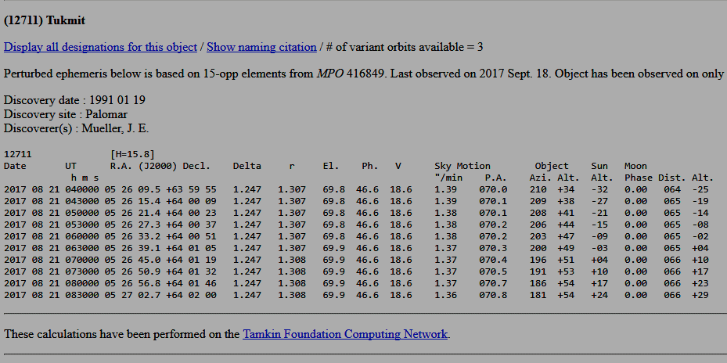
Ephemeris for Tukmit
The page shows the number and name (or Provisional Designation), information about when it was discovered and last observed, comments about whether more observations are required and a table of times and coordinates.
There are several things to check:
- Check “V” (magnitude). Anything brighter than about 16.0 should give you an easy target for measurement.
- Check “Object Alt.” (altitude above the horizon). Go for objects that are above 40 degrees from the horizon at the time of the mission. Closer to the horizon and haze or atmospheric disturbance can reduce the quality of images.
- Check “Sky motion “/min”. Fast objects will leave faint trails and will be difficult to measure. Ideally the object should not move more than about 2 or 3 pixels during the exposure. In practice, speeds up to around 4 or 5 arcseconds per minute should be fine.
- Check the Moon. Phase (a percentage of full), Alt (distance above the horizon) and Dist. (angular distance between the object and the Moon). For a full Moon I would want to be 90° away from the Moon and at first/last quarter 60° away. Slooh will not allow a reservation if it thinks the Moon is too close.
For information:
- “Delta” is the object’s distance from Earth in AU.
- “r” is the object’s distance from the Sun in AU.
- “El.” is “elevation”, the angular distance of the object from the Sun.
- “Ph” is “phase” that specifies the percent illumination of the object (like a Moon phase).
- There may be additional information on the right of the table showing Uncertainty. This is included if the position of the object is unsure (this will be important later in the Tutorial).
The R.A. and Decl columns tell you where the object should be at different times. Keep the ephemeris page open while you look for suitable mission times.

Missions
When you have an object that satisfies all your criteria, reserve the missions.
You should use the T1HM, T2WF, C2WF or A1 systems for your missions. When it comes to measurement you will want at least three images spread out over half-an-hour to see that the object has moved. Schedule the missions spread 10-15 minutes apart. Select the mission times and get the coordinates from the ephemeris.
- Remember you can “hold” missions on the Slooh reservation system so look through the available slots, decide on the set of missions you want and “hold” them until you are ready to finalise them.
If you have scheduled missions spread over half an hour or so, your object will not move far across the field of view. It is best to set up all the missions using the coordinates where the object will be half-way through your group of missions. That way all the images will align together showing the same field of view and the object will appear to move through the centre of the images when you “blink” them later. This will also reduce the effect of any defects in the CCD as different pixels will be showing the object in each mission.
Enter the coordinates into the Slooh reservation slots. We normally use the Multi-Luminance 50s processing recipe for asteroid hunting as this gives multiple 50-second luminance images for each mission. However, for Level 1 it does not matter too much if you use the Generic mission recipe.

Retrieve the FITS
FITS (Flexible Image Transport System) files contain detailed information from the camera. This high precision data is needed to make accurate measurements of position and magnitude. FITS files are generated over a period of hours after the end of missions each night.
In the Slooh Desktop, go to My Past Missions and check that your missions ran OK. Select “view mission log”. When the FITS files are available a FITS button will appear. Click on that button for a list of FITS Files available. For systems like Canary Two, there will be two sets of FITS, one from each of the two telescopes mounted on that pier. You will be interested only in the first group of FITS in the list.
Select the download symbol for each of the required FITS files. The files will appear in your Downloads folder. It’s a good idea to set up a hierarchy of folders for your FITS files, notes and measurements because you will collect a great many of them eventually. Set up a folder to hold your images of this object and move the FITS into it.

Filenames
Filenames of FITS files look like this:
112356m055032_20140406_213041_0_abcdef_l_cal.fit
112356m055032_20140406_213341_3_abcdef_r_cal.fit
The filenames are made up of the following parts:
- The coordinates of the mission: RA=11h 23m 56s, Decl= -05° 50′ 32”. If the Dec is positive, then the “m” will be a “p”. These are the coordinates used to plan the mission they are only an approximation of where the telescope was pointing. The precise coordinates of the centre of the image will be measured later by comparison to a star catalog.
- The date (yyyymmdd): 2014 04 06 and the time (hhmmss): 21:30:41 or 21:33:41. This is the timestamp from when the image file was created and is not a precise indicator of the time the exposure happened. The start of the exposure is contained in “FITS Header” information embedded within the file.
- A sequence number of images within the mission.
- A “random” 6-character string to ensure the name is unique.
- A letter indicating which filter was used:
  - l – luminance.
  - r – red.
  - g – green.
  - b – blue.
  - e – photometric visual.
  - d – photometric infrared.
  - v – photometric red.
- “cal” indicates the image has been calibrated.
- “.fit” is the file type

Identify and Measure
We will need some specialised software to process the images and generate observations.

Application Choice
The initial challenge is to install the necessary software application and develop some skill at using it. The programs have help and tutorials, so I am not going to repeat the fundamentals here but concentrate on “best practice” as applied by the A-Team using Slooh telescopes.
There are two applications available. Astrometrica and Tycho Tracker.
- Astrometrica is a well-established and stable software package that runs on MS Windows. It has been “the standard” for amateur observers for many years. The workflow when using it is quite straight forward and the measurement results are of high quality.
- Tycho Tracker is a relatively recent (2018) introduction but is becoming increasingly popular. It runs on Windows or MAC and offers a much wider range of functions and options. This can make it somewhat more complex to learn and use. It produces high quality results and is much faster than Astrometrica.
I suggest you study the websites of these applications and decide which one to go with. Of course, if you are a MAC user the only choice is Tycho Tracker.
From this point, this Level 1 Tutorial is tailored to Tycho Tracker.

Tycho Tracker
The initial challenge is to install Tycho Tracker and develop some skill at using it. The program has a detailed user guide and tutorials, so I am not going to repeat the fundamentals here.
Tycho Tracker will be used to:
- Open the FITS files and display the images.
- Plate Solve the images. Match the stars in the images to a star catalogue so that the exact sky coordinates of each pixel can be calculated.
- Show “known objects” where asteroids and comets with known orbits are indicated in the image.
- “Blink” the images so that we can clearly identify movement of the target.
- Measure the position and magnitude of the target and send the measurements to the MPC.
Tycho Tracker has a huge range of functions and options. In this tutorial I focus on the basic processes to detect and report on an asteroid or comet from Slooh images.

Installation
Tycho Tracker is a major piece of software, and you will need to be prepared to spend some time learning how to use it. It is also not free. You can download and install the program and use it on the test data provided, but to use it on your own (Slooh) images you will need a license $25 or $50.
Go to the Tycho Tracker website where there are various introductions and videos. On the Download page select the Windows or Mac version. You do not need Find_Orb, Offline solver or SVM.
It is a good idea to watch the “First Time Setup” video to get an idea of what Tycho can do. Have a look at the User Guide and there many videos on YouTube describing how to use it.
Do not follow all the detailed instructions about “settings” as we will focus on settings tailored for the Slooh telescopes.

Settings and Configuration
Tycho Tracker needs to be configured for a range of topics. There are many options, but the following settings will get you started. Open Tycho and select Settings from the top menu.

GPU acceleration
This relates to the use of a graphics processor (GPU) to speed up processing when searching for moving objects. It is not needed for basic “A-Team” activities, but if you have a powerful GPU then activate it, as it will speed up many operations.

Known Objects
There are files called MPCORB.DAT and CometEls.dat, provided by the Minor Planet Centre (MPC), that contain orbital elements of all known asteroids and comets. For each object, the elements are correct as at a specific date (called the Epoch).
It is important to have an up-to-date copy of MPCORB to ensure you have current information about recently discovered objects.
Download the asteroid and comet elements and verify the database. Set the auto update option for every few days in case you forget to do it manually. Other options may be left to default.

Star Catalog
The A-Team normally uses the Gaia DR2 or DR3 catalogue, and suitable settings are:

- The “exclude stars” range may be varied especially in crowded fields when a cutoff of 13 or 14 may be used to limit the excessive number of stars downloaded. Magnitudes less than 9.5 will likely be saturated and provide bad astrometry.
- The selection of VizieR server (for download of catalog entries) is flexible. Strasburg and Harvard are usually reliable.

Tracker
Use of the Tracker (Synthetic Tracking) is discussed later.

ObsCodes
The file ObsCodes.html is provided by the MPC and lists the codes, names and exact geolocations of all observatories used for reporting observations. It is important that this is always up to date. If the orbit calculator finds an observation with an unknown observatory code, it may not warn you with any message and can produce unpredictable results.
- Download Obscodes.html (Ignore “Copy to Find_Orb directory”.

Find_Orb
This is a program, developed by Bill Grey, to calculate orbital elements from observations. It is partially integrated with Tycho and it is used to:
- Calculate ephemeris for close approach objects.
- Calculate residuals to check the quality of your observations.
For Level 1, select the option to use the online service.

Sat ID
This is not used for A-Team work.

FITS Extraction
This is not used for A-Team work.

Observatory
An “observatory” needs to be set up for each of the Slooh telescope/camera combinations you are likely to use for observations. That would normally include Canary Islands T1 & T2WF, Chile 2 and Australia 1.
Select Settings/Observatory to open the Observatory Configuration Window. Select Action/Add Observatory.
- In the Label field put a suitable name to identify the telescope. Make sure “Already have an MPC code” is selected.
- Enter the MPC code (see table below). The official observatory name and location will be filled in automatically.
- Enter the Design, Aperture and Focal Ratio information as shown in the table below then select “Next”.
- Make sure “Refers to beginning of Exposure is selected and camera type is CCD.
- Enter the Gain, Readout noise and Dark current according to the values in the table below. (Note these values are “best efforts” from searching the internet and Slooh guides.)
- Select Finished.
Label

MPC
Code

Design

Apertur
e
(meters)

Focal
Ratio

Gain

Readout
noise

Dark
current

Canary 1

G40

Corrected
Dall
-
Kirkham

0.
508

f/
6.8

1.52

9

5

Cana
ry
2
wf

G40

0.
432

1.52

9

3

Chile 2

W88

0.
432

1.52

9

5

Australia 1

E62

0.5
08

1.52

9

5

Before processing any images, it is important to select the correct observatory otherwise strange results will be obtained. Always check Setting/Observatories before doing anything else.

Report Parameters
These are used to identify you and the telescope to the MPC when submitting reports.
- The format of the name is important. Observations submitted to the Minor Planet Centre will eventually be published in official scientific documents and your name will be indexed in the NASA Astrophysics Data System (http://cdsads.u-strasbg.fr/) (ADS).
- The format must be first initial, full-stop, blank, (second initial, full stop, blank), surname.
Your email address is where an acknowledgement or error message will be sent when you submit a report.

Image directories
This is where you want the calibrated & aligned images to be stored. A suitable setting would be:

Autorun
Not normally used in the A-Team context.

Identify & Measure

Data Reduction
Open Tycho and check Settings/Observatory to ensure the correct telescope is Active (double click on it).
In the Image manager, select List/Add images. Select all the images from your missions. (For the moment it does not matter if they are a mix of luminance and colour filters).
Select Action/View Images to open the image display. Note the various controls for zoom, contrast and intensity and the Display/Large view option.
Select each of your images in the Image Manager list to see it displayed. Discard (delete) any that are of seriously bad quality.

Calibrate
Select Action/Calibrate Images.
Slooh automatically calibrates images with Dark, Flat and Bias frames so set these to “Skip”. Pseudo flat is optional but may assist if the Slooh flat is not very good. Normalize and “Fix hot pixels” should be checked.

Press OK and Tycho will report its progress in performing the calibration tasks.

Plate Solve
Select Action/Plate Solve images.
The objective is to establish the sky coordinates of the image so that the precise position of each pixel can be calculated. This is done by downloading part of the star catalogue and matching the positions of the stars in your images. The settings shown below should work for all the Slooh telescopes.
Select Start and Tycho will report its progress in performing the Plate Solve (using the online Gaia DR2 catalogue as selected earlier). This may take some time.

Align
Select Action/Align Images.
The settings for alignment are as shown below, then select “OK”.
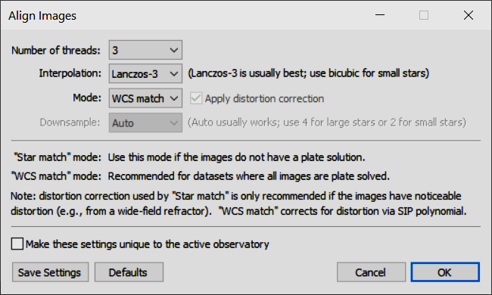
All the images are aligned so that the field of view is identical in each image. These aligned images are placed in a separate directory and Tycho will tell you where they are.

View
In the Image Manager, reload the aligned images (they will be automatically reloaded if you selected “Auto load output files into image manager” under Settings/Image Directories.)
If the Image Viewer is not already open, select Action/View Images.

Identify and Measure
Tycho provides many ways to identify and measure targets. In level 1 it is assumed you have a reasonably bright, known object target and a simple approach will suffice.

Identify Known Object
In the Image Viewer select File/Load known objects. Various windows may open as Tycho refreshes the MPCORB database, then scans to check which objects should appear in your images. Eventually a “Known Objects” window will appear with a list of possible objects. One of them should be your target.
Right click on the line containing your target and select View Stacked Image. The Image Viewer should now show your target near the centre of the image. It is in fact an image made by stacking all your images. You may want to experiment with the various Image Manager controls to adjust Zoom, Contrast, Intensity to obtain a clear view of your target.
Double click on the target to ensure the target is centred then right-click inside the image viewer and select Create Track – current position.
The Track-Navigator window will open. Double-click on the newly created track (or right click/Verify Track). The Verify Track dialog will open. Set Animation to “Follow Target” and “3 stacks”. The track information has been calculated from the object’s orbit. “Num obs to generate” should also be 3.
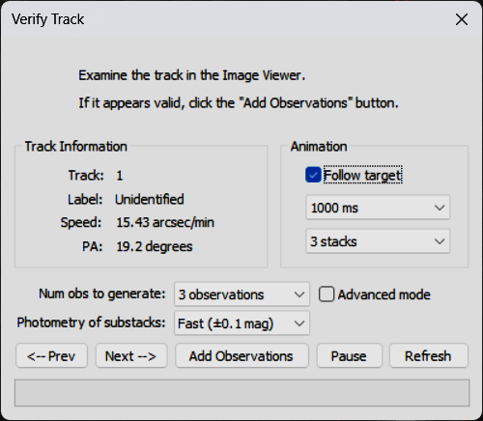
The Image Viewer should now “blink”, showing your target “tracked” in each of three different positions.

Create Observation
Check that the target is visible in the centre of the box at each “blink” then select Add Observations (in the Verify Track dialog).
The Object Designation window will open. If not already filled in, set the Permanent ID to the object’s number, or set the Provisional ID if it does not have a number. Select OK.
The Observations - All Targets window will open showing your three observations. You can select each of them to see the image they came from.

Residuals and Quality

What are Residuals?
A “Residual” is the difference between where an object should be according to its orbit and where an observation measures it to be. There is almost always some difference because:
- The images we use for measuring suffer from the effects of “seeing” and the position of the object is estimated by trying to fit a nice smooth theoretical brightness curve (Point Spread Function – PSF) to a set of square pixels with values that include quite a lot of noise.
- The images have been calibrated using the measured positions of stars (same problem as measuring the position of the asteroid) and the recorded position of stars in a catalogue that may have some random or systematic errors in it.
- The predicted position of the object is only as good as the accuracy of the orbit data, and this has been estimated using lots of earlier observations all of which had similar deficiencies as ours.

For now, we just want to have an idea that our measurements are reasonably consistent with the known orbit of our target.

Check Residuals
Tycho offers two ways to check your residuals.

Self-consistency
This is a check to see whether your three observations are in a more-or-less straight line. The object will not noticeably deviate from a straight line and consistent speed during the period of your missions.
Select your three observations in the Observations – All Targets window then right-click/Check Residuals. Find_Orb will attempt to calculate an orbit using just your three observations. The results are shown in an Orbit window. The values of dRA and dDec show how much your observations deviate from the ideal line. You will be hoping for values less than ±0.5 arcseconds.

Consistency with others
This is a check to see if your observations can be merged with those from other observers to produce an orbit.
Select your three observations in the Observations – All Targets window then right-click/View with Published Observations. Tycho will download the existing observations for this object and show them, together with yours, in the Text Form Observations window.
“Auto truncate…” (bottom left) should be checked, then select Compute Orbit.
The Orbit window will appear, this time with all the observations, (most recent at the bottom) with their residuals in the dRA and dDec columns.

Quality
If everything has gone reasonably well your residuals should be less than 1.0″. If they are less than 0.5″, well done!
If they are all consistently over 1″ there may be a good reason. If they are scattered (large and small, positive and negative), try doing the measurements again.
There will be lots more discussion in later tutorials about the quality of observations as demonstrated by their residuals.

Reports and Publications

Generate Report
In the Observations – All Targets window select Report/Generate ADES Report. For Level 1, it is sufficient at this point to make a copy of your observations and e-mail them to your A-Team tutor together an explanation of why you chose that target and comments about any problems you had.
In the ADES Report select “copy to clipboard” and paste the text into the e-mail.

Conclusion
Now you have completed the basic workflow, practice with a variety of objects and using different Slooh telescopes.
Originally published April 2014. Last update Aug 2025.
Tony Evans

